

DEPARTMENT OF MECHANICAL AND INDUSTRIAL ENGINEERING

Strap Rest 3

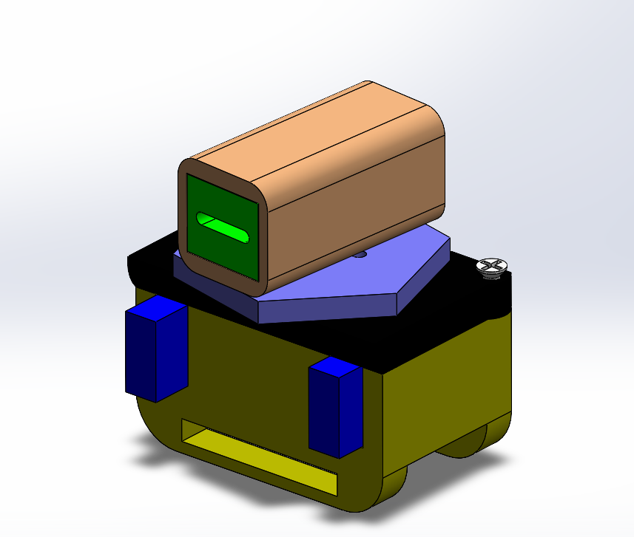

By: Kisei Mano & Punith Molakalu

Instructor: Swapnil Moon

Teacher Assistant: Tahir Ali Tahir Ali

Date of Submission: May 14th, 2025

**ME635-102: Computer Aided Design**

**SPRING 2025**

# Table of Contents

Table of Contents 2

Executive summary 3

Functional requirements and concept development 4

CAD models and assemblies 6

FEA 13

Assumptions 14

Study Properties 14

Units 15

Material Properties 16

**Loads and Fixtures** 17

Mesh information 18

Mesh information - Details 18

Study Results 19

Prototype manufacturing 22

Results from Testing 29

**Testing Parameters** 29

**Limitations Observed** 29

Design Evaluation 30

Open-Source repository 30

Conclusion 31

# Executive summary

This project presents the design and prototyping of a 3D-printed assistive device specifically developed for individuals without hands. The primary goal of this device is to enable users to perform essential tasks such as eating and writing—activities that typically require a stable grip and controlled wrist movement.

Rather than mimicking a full prosthetic hand, the design focuses on creating a wrist-mounted mechanism that securely holds and rotates a utensil (like a spoon, fork, or pen). The rotation is user-controlled through two mechanical buttons that drive a gear system, enabling clockwise and counterclockwise movement. Springs are used not for motion return but to reset the position of the buttons after each actuation. The utensil is held in a dedicated top-mounted holder with the option to add a salver interface for extra stability during use.

This approach allows for practical, low-effort execution of specific tasks without requiring a full prosthetic structure. The device is designed to be lightweight, simple, affordable, and customizable through 3D printing, making it accessible for daily use by individuals with upper-limb differences.

# Functional requirements and concept development

**Purpose:**  
 To provide a wrist-mounted assistive device that allows individuals without hands to perform tasks such as eating and writing independently.

Functional Requirements & Design Specifications:  
 - Wrist-mounted housing with ergonomic fit  
 - Mechanical rotation of utensil via two buttons  
 - Lightweight design (under 300g)  
 - Durable materials: PLA for structure, TPU for interfaces  
 - ±45° rotational range with a mechanical stopper  
 - Spring-loaded button retraction (not utensil reset)  
 - Modular spoon/fork holder on top  
 - Optional salver interface for utensil stabilization

**Sketches:**

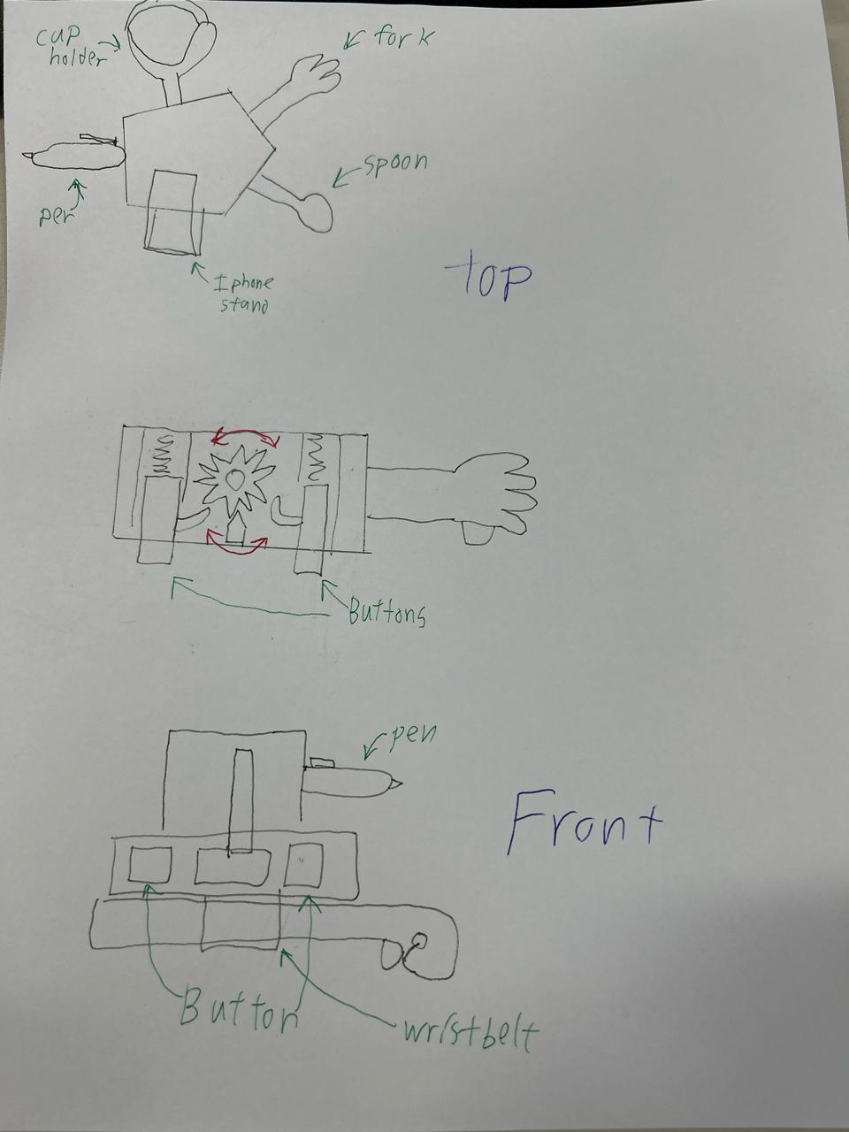

# CAD models and assemblies

**Wrist Mount** :- Acts as the main housing that mounts onto the user's wrist.

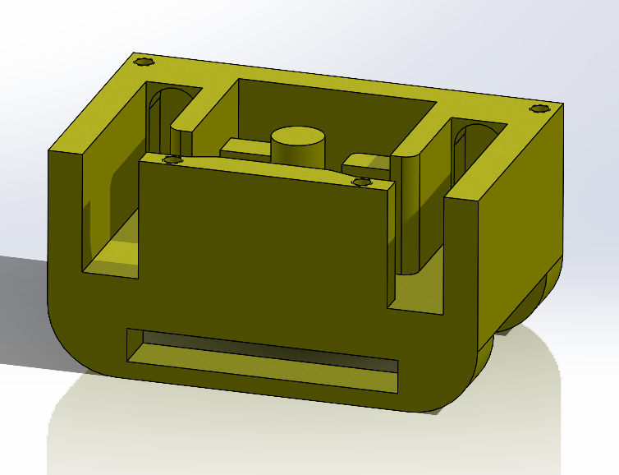

**Circular Gear** :- Enables the utensil to rotate in clockwise and counterclockwise directions.

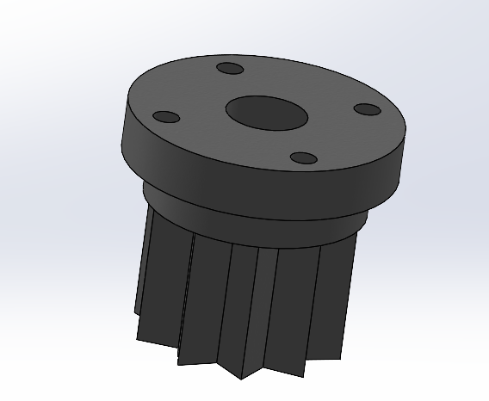

**Stopper:- it is combined with the PLA and TPU**

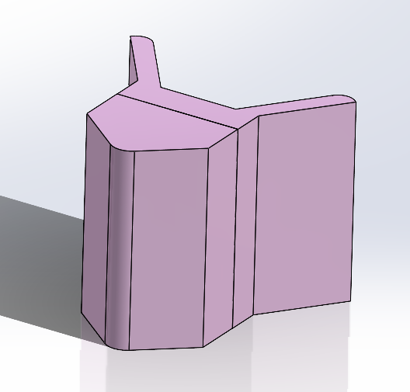

**Buttons:-** Allow the user to manually rotate the gear in either direction.

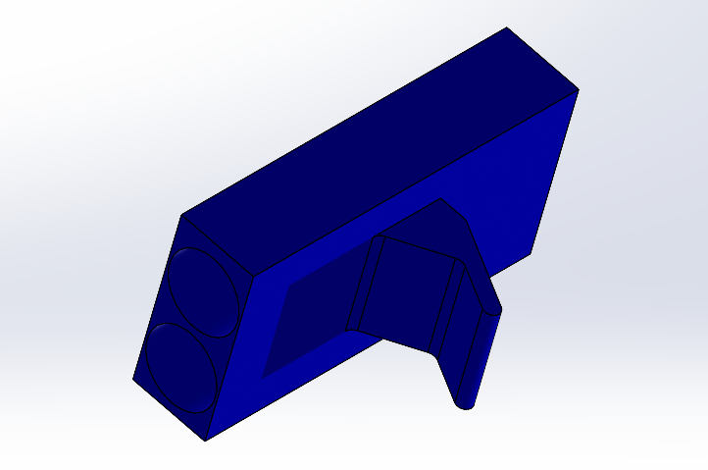

**Spring:-** Resets the buttons to their original position after each actuation.

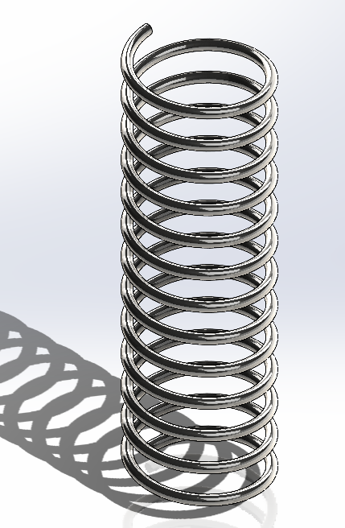

**Salver:-** Stabilizes the utensil while in use, preventing excessive movement.

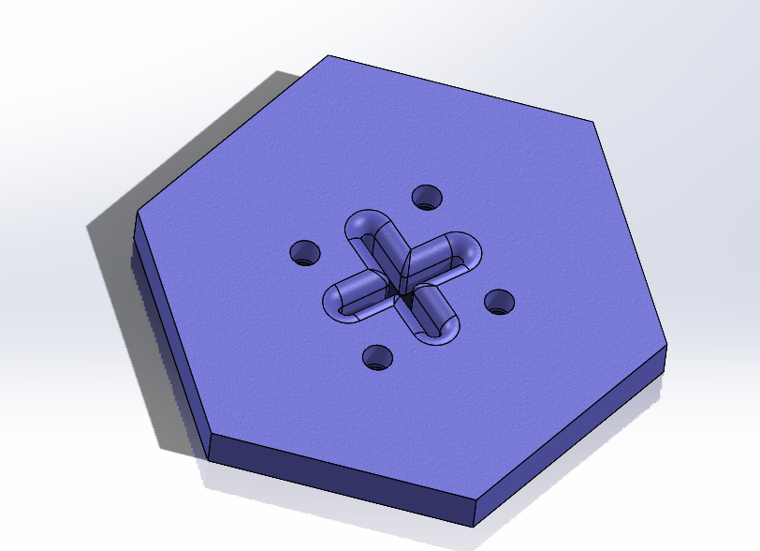

**Futa:-** Acts as a protective cap or cosmetic enclosure.

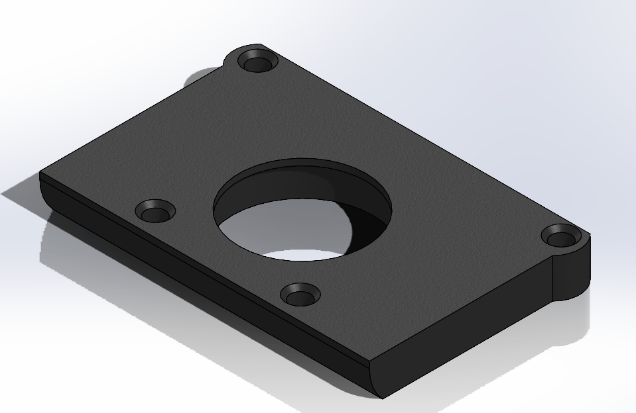

**Spoon_Holder:-** Holds the spoon or fork securely during use.

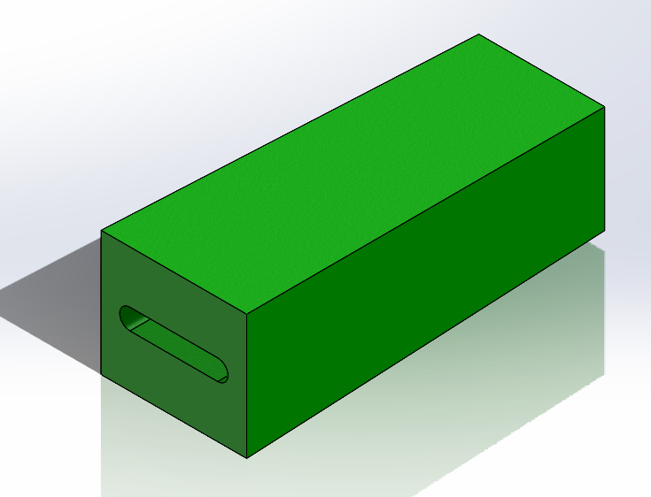

**Holder_Mount:-** Connects the spoon holder to the gear mechanism.

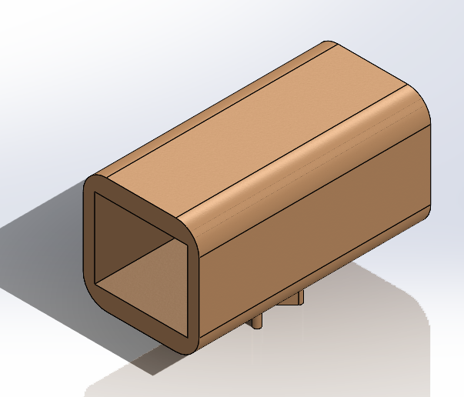

**Pen_Holder:-** Enables the user to write using a pen or pencil.

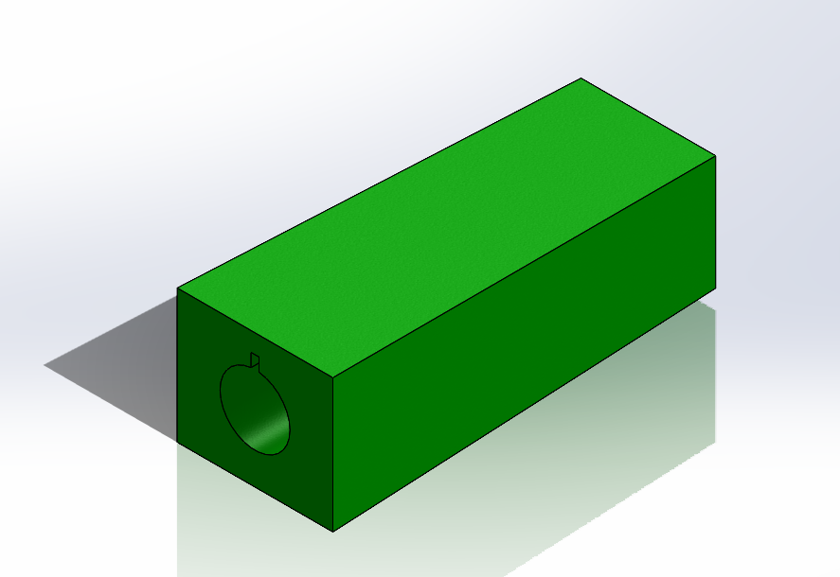

**Mobile_Holder:**- Holds a small device like a phone.

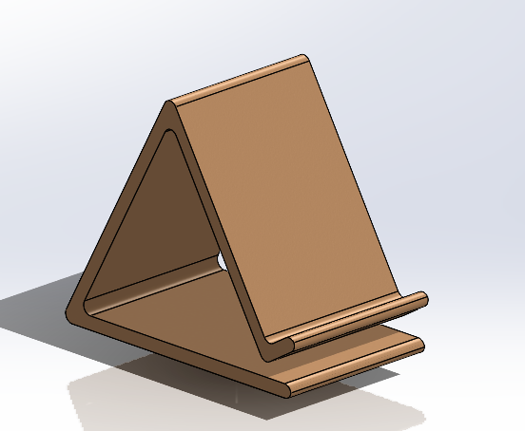

**Flat Screw:-** Joins parts securely within the assembly.

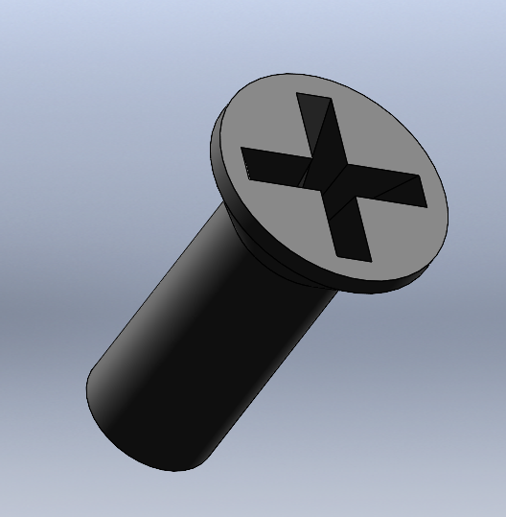

Provide an image of the exploded view of the assembly.

Exploded View Of Full assembly:

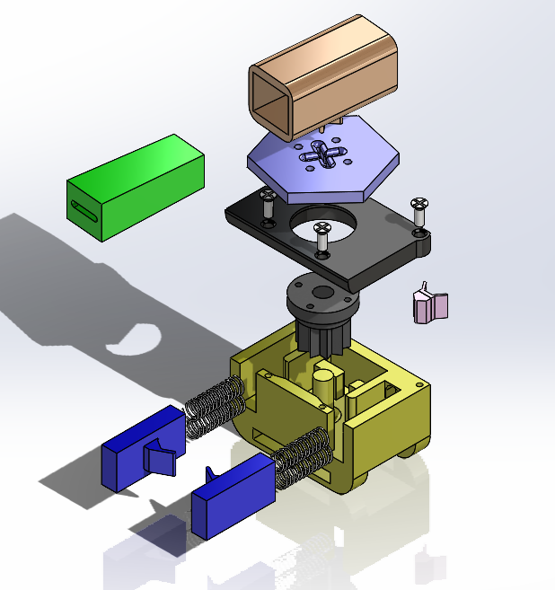

Exploded View Of Full assembly Including Replaceable Parts:

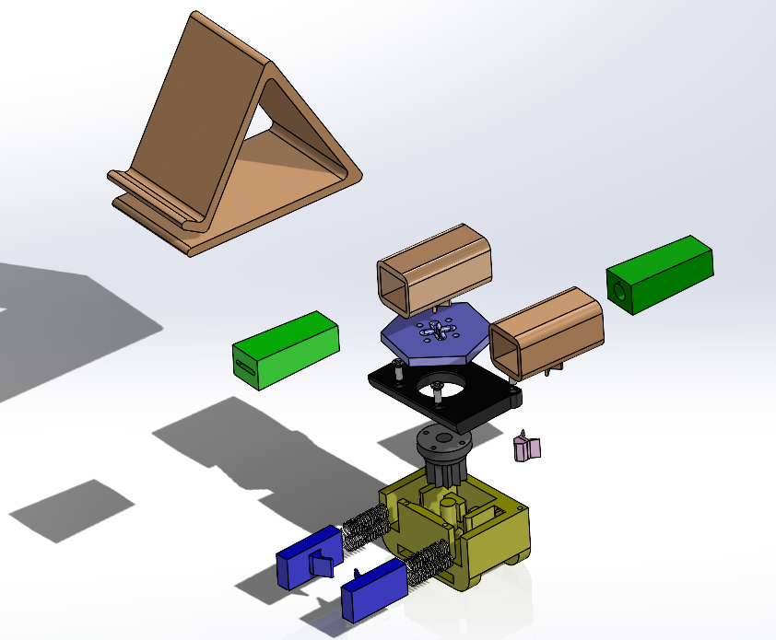

Assembly drawing with BOM

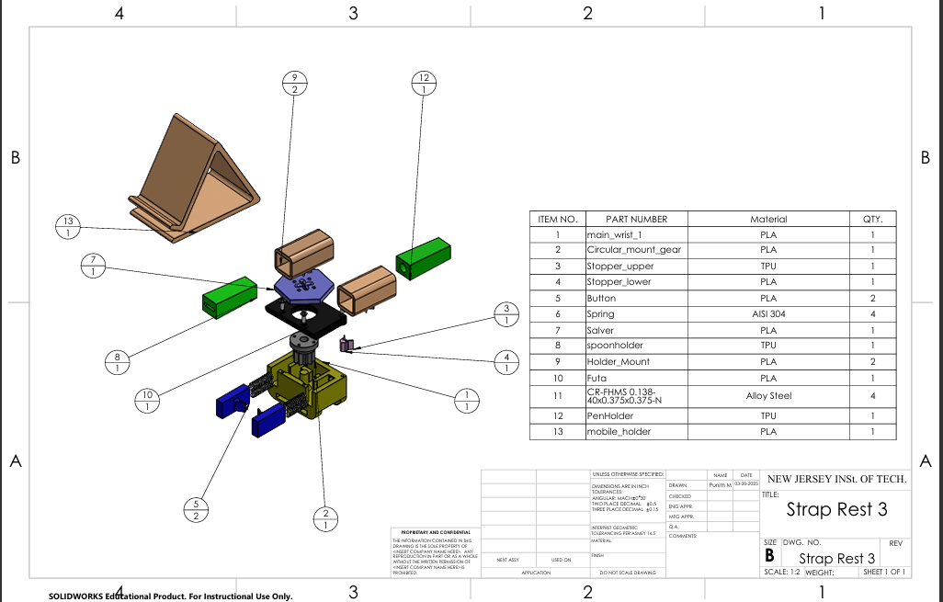

Rendered image of the Assembly:

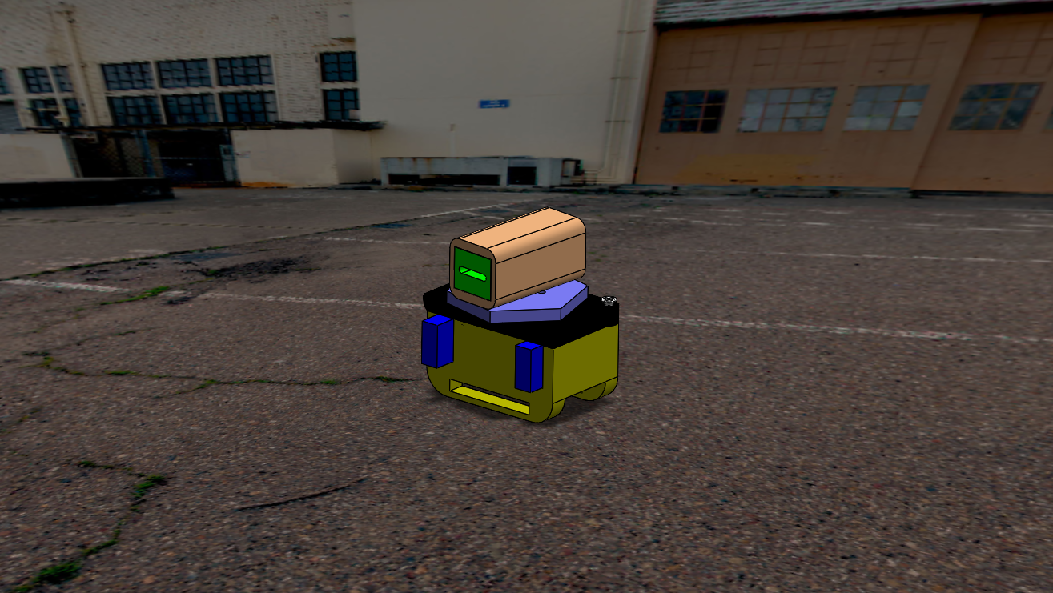

# FEA

|  |  |  |  |
| --- | --- | --- | --- |
|  | |  | | --- | | **Simulation of stopper**  **Date: Tuesday, May 13, 2025 Designer: Solidworks**  **Study name: Static 1**  **Analysis type: Static** | | Table of Contents  Assumptions 2  Study Properties 2  Units 2  Material Properties 3  Loads and Fixtures 4  Connector Definitions 4  Mesh information 5  Study Results 6 | |
|  |

|  |
| --- |
| Assumptions |

|  |  |  |  |  |  |  |  |  |  |  |  |  |  |  |  |  |  |  |  |  |  |  |  |  |  |  |  |  |  |  |  |  |  |  |
| --- | --- | --- | --- | --- | --- | --- | --- | --- | --- | --- | --- | --- | --- | --- | --- | --- | --- | --- | --- | --- | --- | --- | --- | --- | --- | --- | --- | --- | --- | --- | --- | --- | --- | --- |
| Study Properties  |  |  | | --- | --- | | Study name | Static 1 | | Analysis type | Static | | Mesh type | Solid Mesh | | Thermal Effect: | On | | Thermal option | Include temperature loads | | Zero strain temperature | 298 Kelvin | | Include fluid pressure effects from SOLIDWORKS Flow Simulation | Off | | Solver type | Automatic | | Inplane Effect: | Off | | Soft Spring: | Off | | Inertial Relief: | Off | | Incompatible bonding options | Automatic | | Large displacement | Off | | Compute free body forces | On | | Friction | Off | | Use Adaptive Method: | Off | | Result folder | SOLIDWORKS document (C:\Users\Punith\Downloads\Finilized model\Finilized model) | |

|  |  |  |  |  |  |  |  |  |  |  |
| --- | --- | --- | --- | --- | --- | --- | --- | --- | --- | --- |
| Units  |  |  | | --- | --- | | Unit system: | SI (MKS) | | Length/Displacement | mm | | Temperature | Kelvin | | Angular velocity | Rad/sec | | Pressure/Stress | N/mm^2 (MPa) | |

|  |  |  |  |  |  |  |  |  |  |  |  |  |  |  |  |  |  |  |  |  |  |  |  |  |  |  |  |  |  |  |  |  |  |  |  |  |  |  |  |  |  |  |  |  |  |  |  |  |  |  |  |  |  |  |  |  |  |  |  |  |  |  |  |  |  |  |  |  |  |  |  |  |  |  |  |  |  |  |  |  |  |  |  |  |  |  |  |  |  |  |  |  |  |  |  |  |  |  |  |  |
| --- | --- | --- | --- | --- | --- | --- | --- | --- | --- | --- | --- | --- | --- | --- | --- | --- | --- | --- | --- | --- | --- | --- | --- | --- | --- | --- | --- | --- | --- | --- | --- | --- | --- | --- | --- | --- | --- | --- | --- | --- | --- | --- | --- | --- | --- | --- | --- | --- | --- | --- | --- | --- | --- | --- | --- | --- | --- | --- | --- | --- | --- | --- | --- | --- | --- | --- | --- | --- | --- | --- | --- | --- | --- | --- | --- | --- | --- | --- | --- | --- | --- | --- | --- | --- | --- | --- | --- | --- | --- | --- | --- | --- | --- | --- | --- | --- | --- | --- | --- | --- |
| Material Properties  |  |  |  |  |  |  | | --- | --- | --- | --- | --- | --- | | **Model Reference** | **Properties** | **Components** | | | | |  | |  |  | | --- | --- | | **Name:** | **TPU** | | **Model type:** | **Linear Elastic Isotropic** | | **Default failure criterion:** | **Unknown** | | **Yield strength:** | **20 N/mm^2** | | **Tensile strength:** | **35 N/mm^2** | | **Compressive strength:** | **40 N/mm^2** | | **Elastic modulus:** | **50 N/mm^2** | | **Poisson's ratio:** | **0.45** | | **Mass density:** | **1.2 g/cm^3** | | **Shear modulus:** | **17.2 N/mm^2** | | **SolidBody 1(#0-80 Tapped Hole1)(Stopper_2-1)** | | | | | **Curve Data:N/A** | | | | | | |  | |  |  | | --- | --- | | **Name:** | **PLA** | | **Model type:** | **Linear Elastic Isotropic** | | **Default failure criterion:** | **Unknown** | | **Tensile strength:** | **30 N/mm^2** | | **Compressive strength:** | **60 N/mm^2** | | **Elastic modulus:** | **2,000 N/mm^2** | | **Poisson's ratio:** | **0.394** | | **Mass density:** | **1.02 g/cm^3** | | **Shear modulus:** | **318.9 N/mm^2** | | **SolidBody 1(#0-80 Tapped Hole1)(Stopper_2t-1)** | | | | | **Curve Data:N/A** | | | | | | |  | |  |  | | --- | --- | | **Name:** | **Alloy Steel** | | **Model type:** | **Linear Elastic Isotropic** | | **Default failure criterion:** | **Max von Mises Stress** | | **Yield strength:** | **620.422 N/mm^2** | | **Tensile strength:** | **723.826 N/mm^2** | | **Elastic modulus:** | **210,000 N/mm^2** | | **Poisson's ratio:** | **0.28** | | **Mass density:** | **7.7 g/cm^3** | | **Shear modulus:** | **79,000 N/mm^2** | | **Thermal expansion coefficient:** | **1.3e-05 /Kelvin** | | **SolidBody 1(CirPattern1)(pan cross head_am-1),**  **SolidBody 1(CirPattern1)(pan cross head_am-2)** | | | | | **Curve Data:N/A** | | | | | | |

|  |  |  |  |  |  |  |  |  |  |  |  |  |  |  |  |  |  |  |  |  |  |  |  |  |  |  |  |  |  |  |  |  |  |  |  |  |  |  |  |  |  |  |  |  |  |  |  |  |  |  |  |  |  |  |  |  |  |  |  |  |  |  |  |  |  |
| --- | --- | --- | --- | --- | --- | --- | --- | --- | --- | --- | --- | --- | --- | --- | --- | --- | --- | --- | --- | --- | --- | --- | --- | --- | --- | --- | --- | --- | --- | --- | --- | --- | --- | --- | --- | --- | --- | --- | --- | --- | --- | --- | --- | --- | --- | --- | --- | --- | --- | --- | --- | --- | --- | --- | --- | --- | --- | --- | --- | --- | --- | --- | --- | --- | --- |
| **Loads and Fixtures**  | **Fixture name** | **Fixture Image** | **Fixture Details** | | --- | --- | --- | | **Fixed-1** |  | |  |  | | --- | --- | | Entities: | **4 face(s)** | | Type: | **Fixed Geometry** | | | **Resultant Forces**   |  |  |  |  |  | | --- | --- | --- | --- | --- | | **Components** | **X** | **Y** | **Z** | **Resultant** | | **Reaction force(N)** | **-0.00916296** | **-2.42242** | **15.1829** | **15.3749** | | **Reaction Moment(N.m)** | **0** | **0** | **0** | **0** | | | | | **Roller/Slider-1** |  | |  |  | | --- | --- | | Entities: | **6 face(s)** | | Type: | **Roller/Slider** | | | **Resultant Forces**   |  |  |  |  |  | | --- | --- | --- | --- | --- | | **Components** | **X** | **Y** | **Z** | **Resultant** | | **Reaction force(N)** | **13.0303** | **2.56404** | **0.205996** | **13.2818** | | **Reaction Moment(N.m)** | **0** | **0** | **0** | **0** | | | |  | **Load name** | **Load Image** | **Load Details** | | --- | --- | --- | | **Force-1** |  | |  |  | | --- | --- | | Entities: | **1 face(s)** | | Type: | **Apply normal force** | | Value: | **20 N** | | |

|  |
| --- |
|  |

|  |  |  |  |  |  |  |  |  |  |  |  |  |  |  |  |  |  |  |  |  |  |  |  |  |  |  |  |  |  |  |  |  |  |  |  |  |
| --- | --- | --- | --- | --- | --- | --- | --- | --- | --- | --- | --- | --- | --- | --- | --- | --- | --- | --- | --- | --- | --- | --- | --- | --- | --- | --- | --- | --- | --- | --- | --- | --- | --- | --- | --- | --- |
| Mesh information  |  |  | | --- | --- | | Mesh type | Solid Mesh | | Mesher Used: | Standard mesh | | Automatic Transition: | Off | | Include Mesh Auto Loops: | Off | | Jacobian points for High quality mesh | 4 Points | | Element Size | 0.810528 mm | | Tolerance | 0.0405264 mm | | Mesh Quality | High | | Remesh failed parts independently | Off | | Reuse mesh for identical parts in an assembly (Blended curvature-based mesher only) | Off |  Mesh information - Details  |  |  | | --- | --- | | Total Nodes | 15706 | | Total Elements | 9533 | | Maximum Aspect Ratio | 16.416 | | % of elements with Aspect Ratio < 3 | 97.5 | | Percentage of elements with Aspect Ratio > 10 | 0.0524 | | Percentage of distorted elements | 0.021 | | Time to complete mesh(hh;mm;ss): | 00:00:04 | | Computer name: |  | |

|  |  |  |  |  |  |  |  |  |  |  |  |  |  |  |  |  |  |  |  |  |  |  |  |  |  |  |  |  |  |  |  |  |  |  |  |  |
| --- | --- | --- | --- | --- | --- | --- | --- | --- | --- | --- | --- | --- | --- | --- | --- | --- | --- | --- | --- | --- | --- | --- | --- | --- | --- | --- | --- | --- | --- | --- | --- | --- | --- | --- | --- | --- |
| Study Results  | Name | Type | Min | Max | | --- | --- | --- | --- | | Stress1 | VON: von Mises Stress | 1.663e-03N/mm^2 (MPa)  Node: 13694 | 2.823e+00N/mm^2 (MPa)  Node: 14671 | | **stopper-Static 1-Stress-Stress1** | | | |  | Name | Type | Min | Max | | --- | --- | --- | --- | | Displacement1 | URES: Resultant Displacement | 0.000e+00mm  Node: 51 | 1.033e-01mm  Node: 4694 | | **stopper-Static 1-Displacement-Displacement1** | | | |  | Name | Type | Min | Max | | --- | --- | --- | --- | | Strain1 | ESTRN: Equivalent Strain | 1.115e-08  Element: 8624 | 2.800e-02  Element: 1570 | | **stopper-Static 1-Strain-Strain1** | | | | |

# Prototype manufacturing

Equipment Used:

* 3D Printer (AnyCubic Kobra 3 and UltiMaker3)

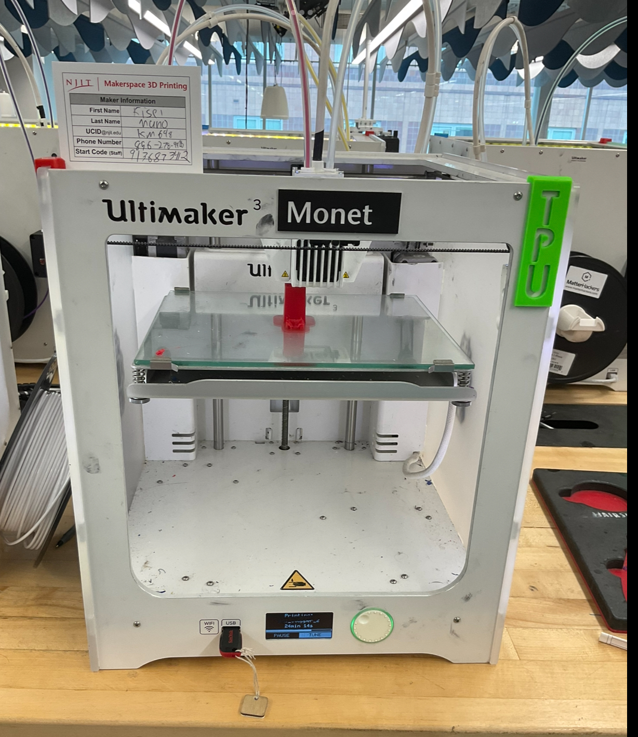

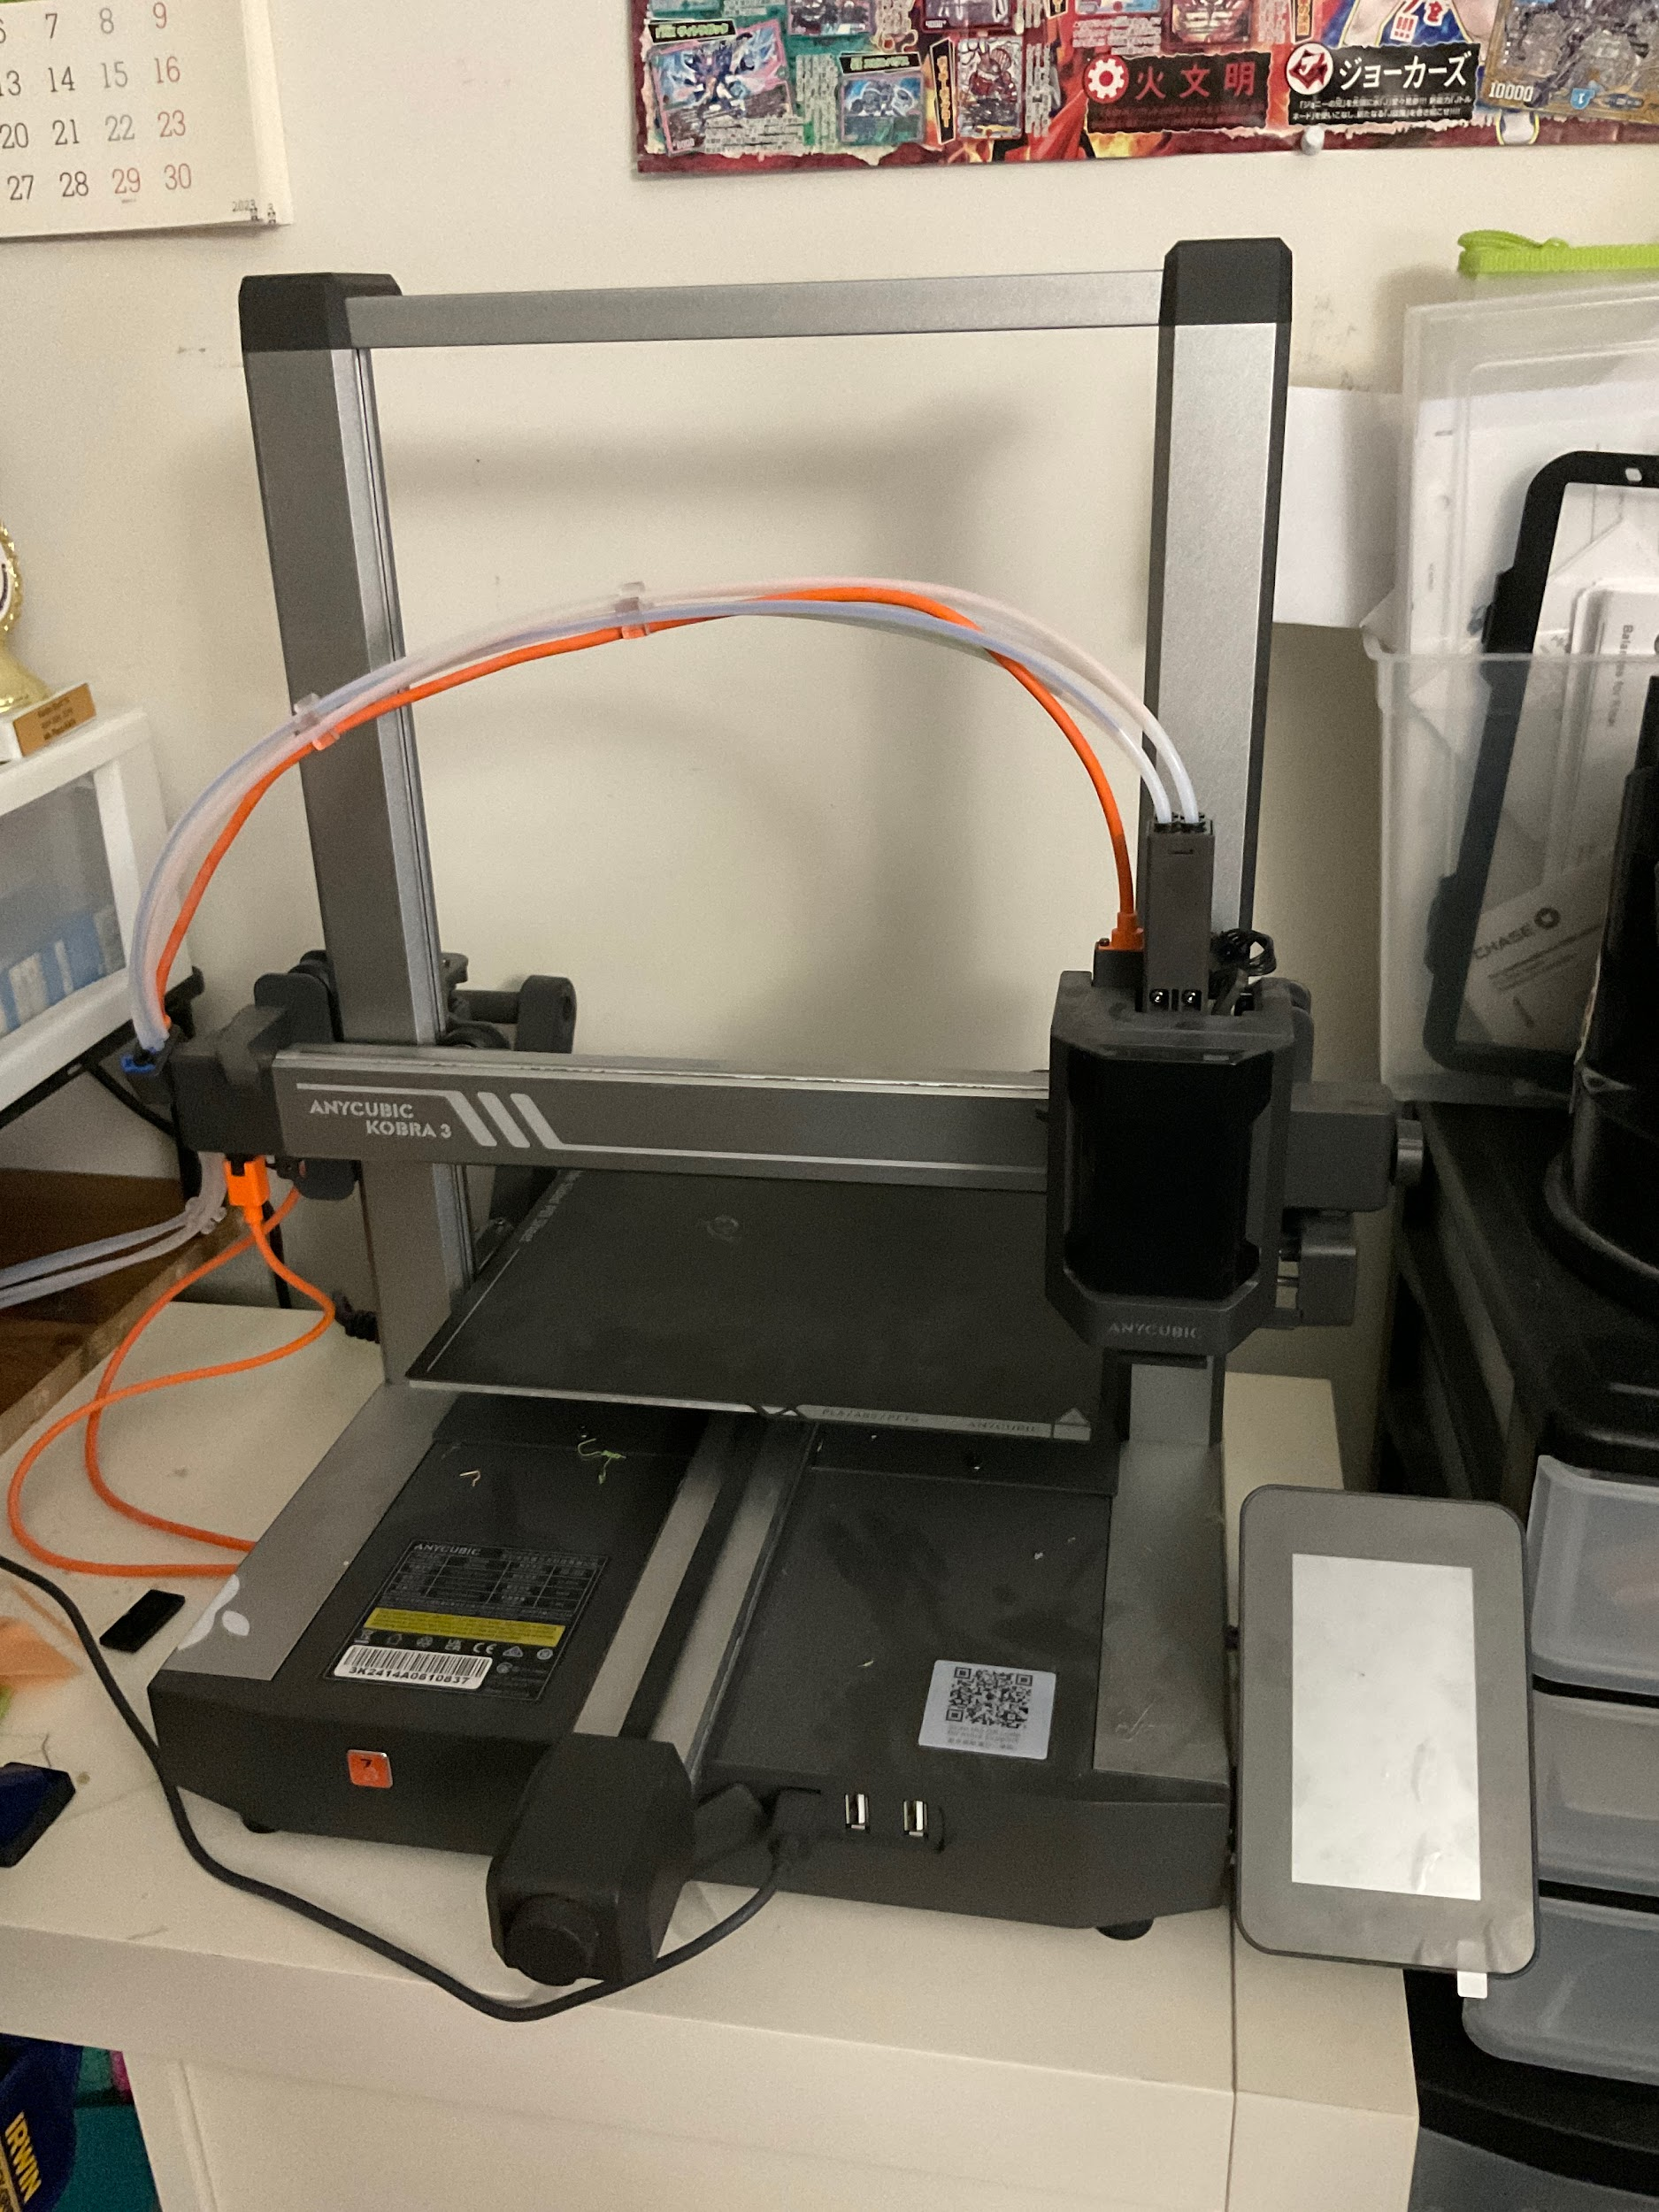

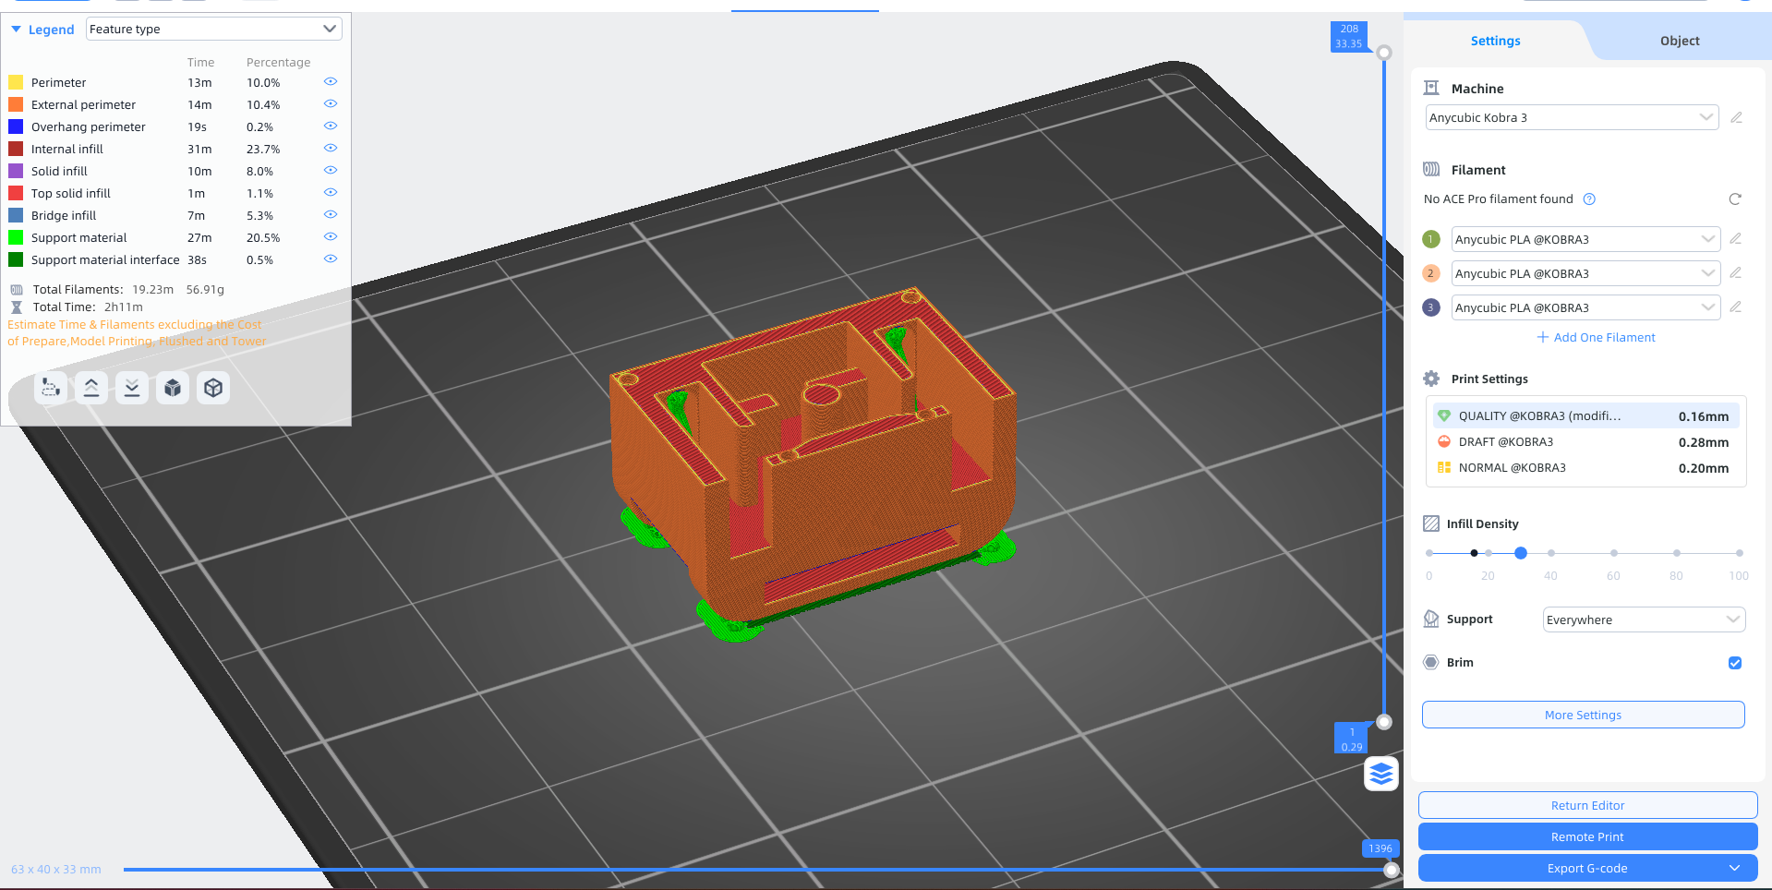

List of Material:

* PLA plastic Filament for solid parts
* TPU plastic Filament for flexible parts

**Wrist Mount:**

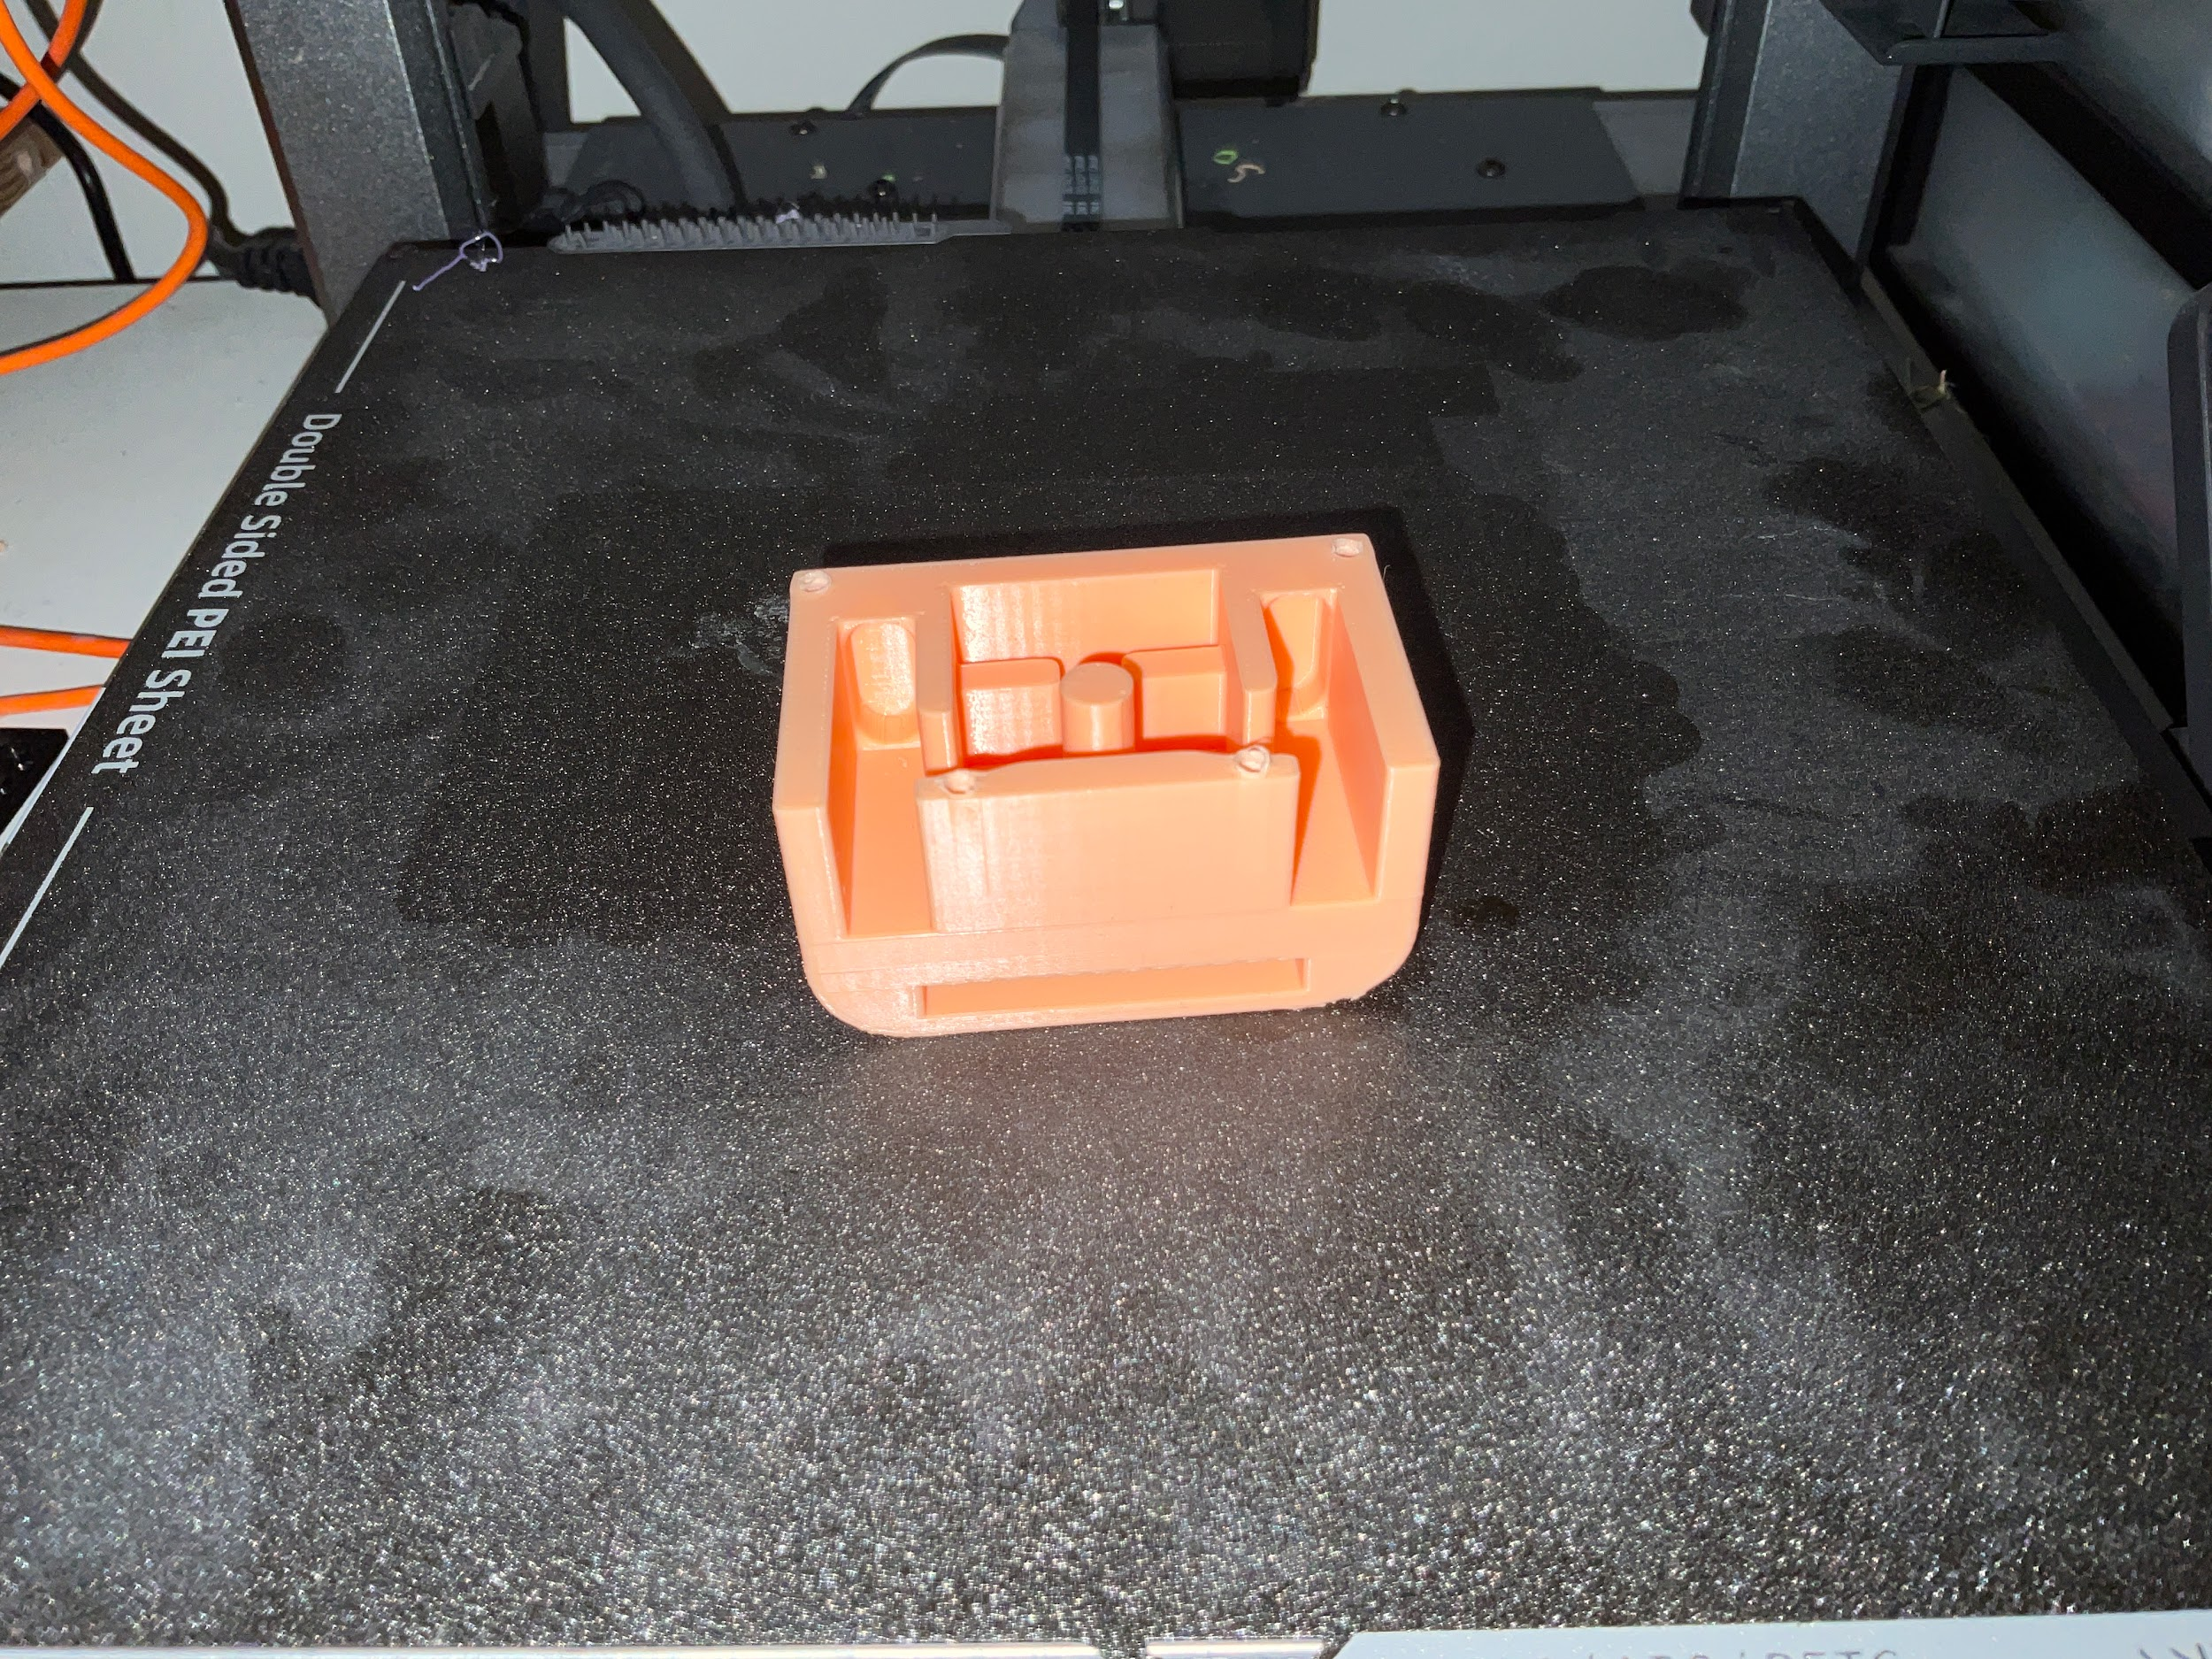

**Futa:**

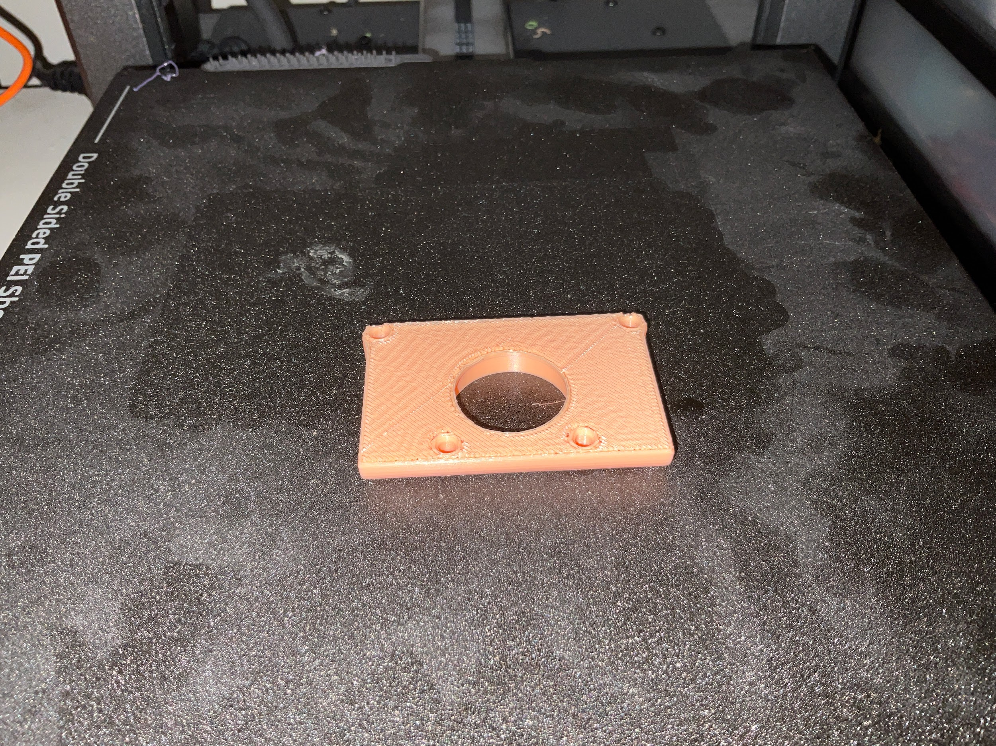

**Circular Gear with Shaft:**

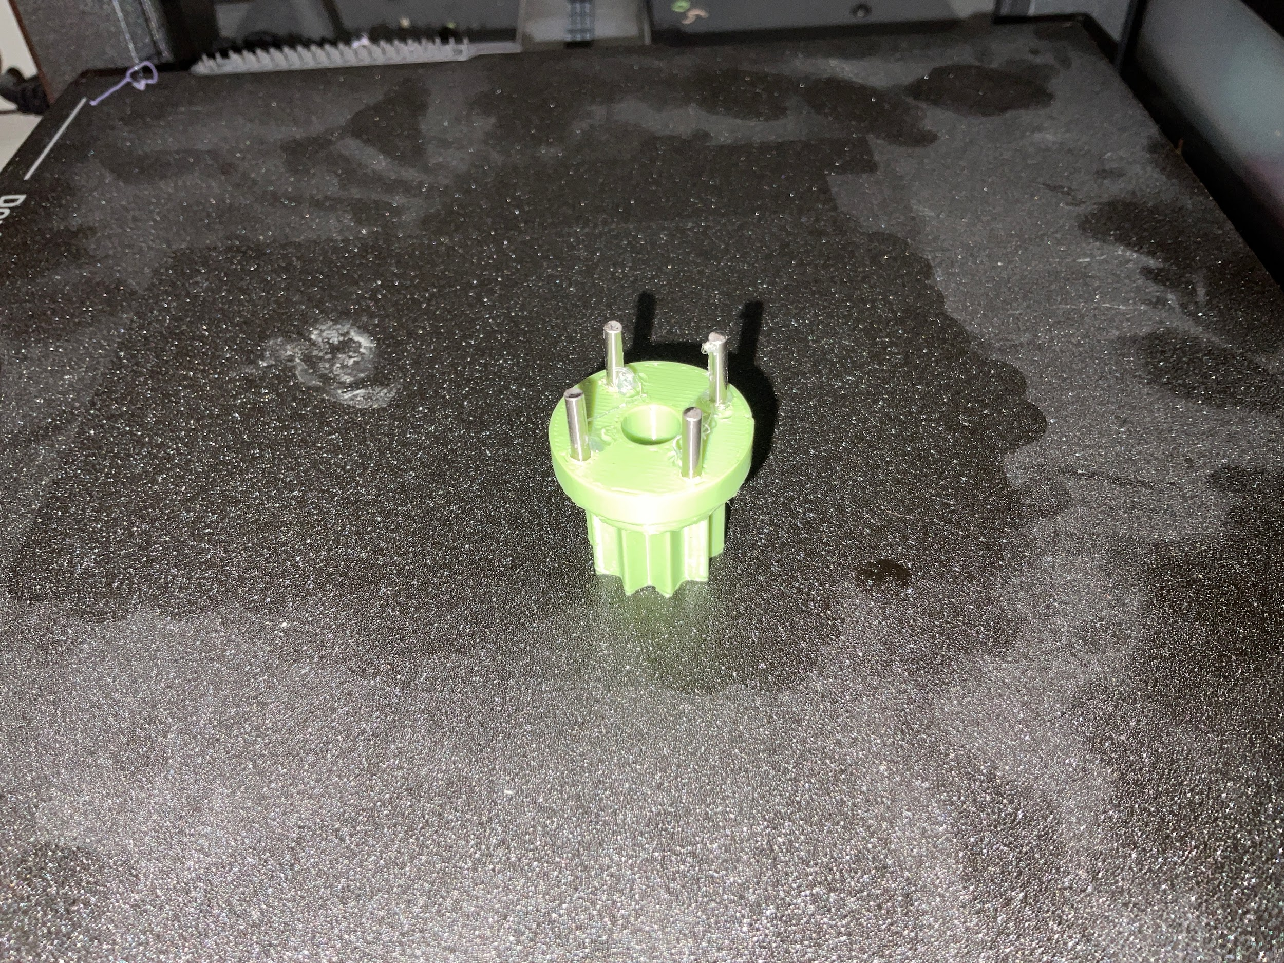

**Buttons with springs:**

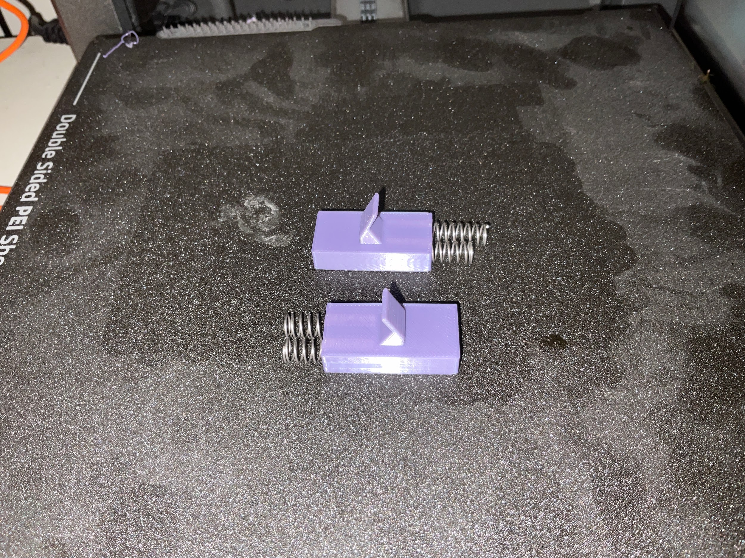

**Stopper:**

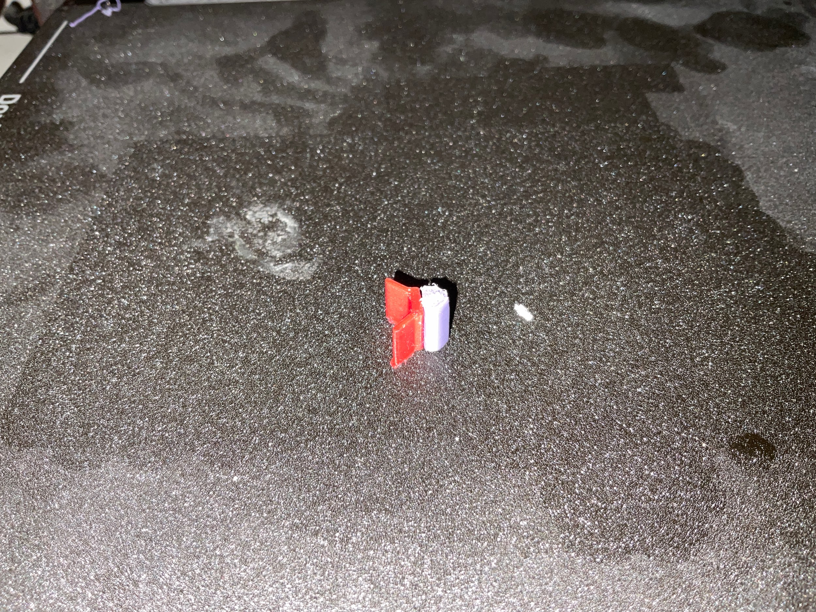

**Salver:**

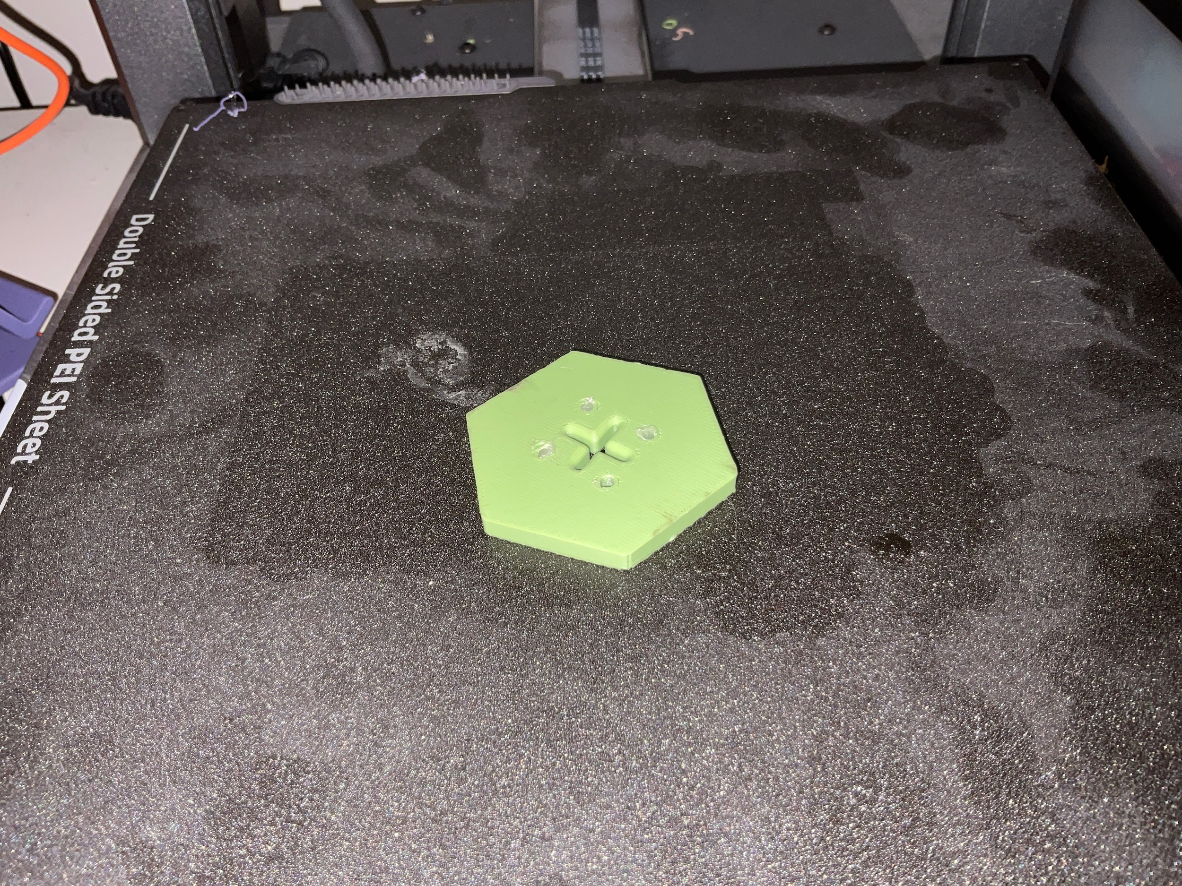

**Spoon holder and Holder Mount together:**

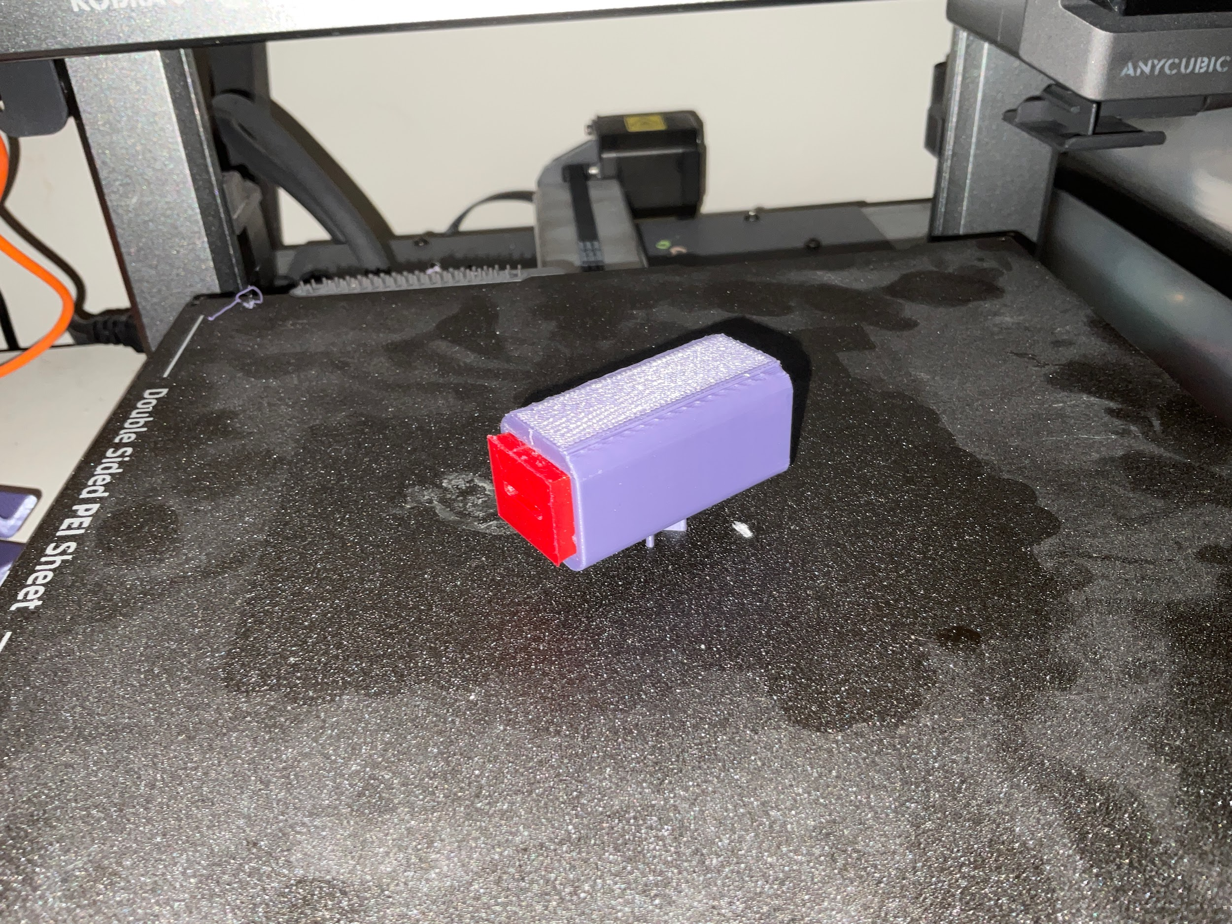

**Pen Holder and Holder Mount together:**

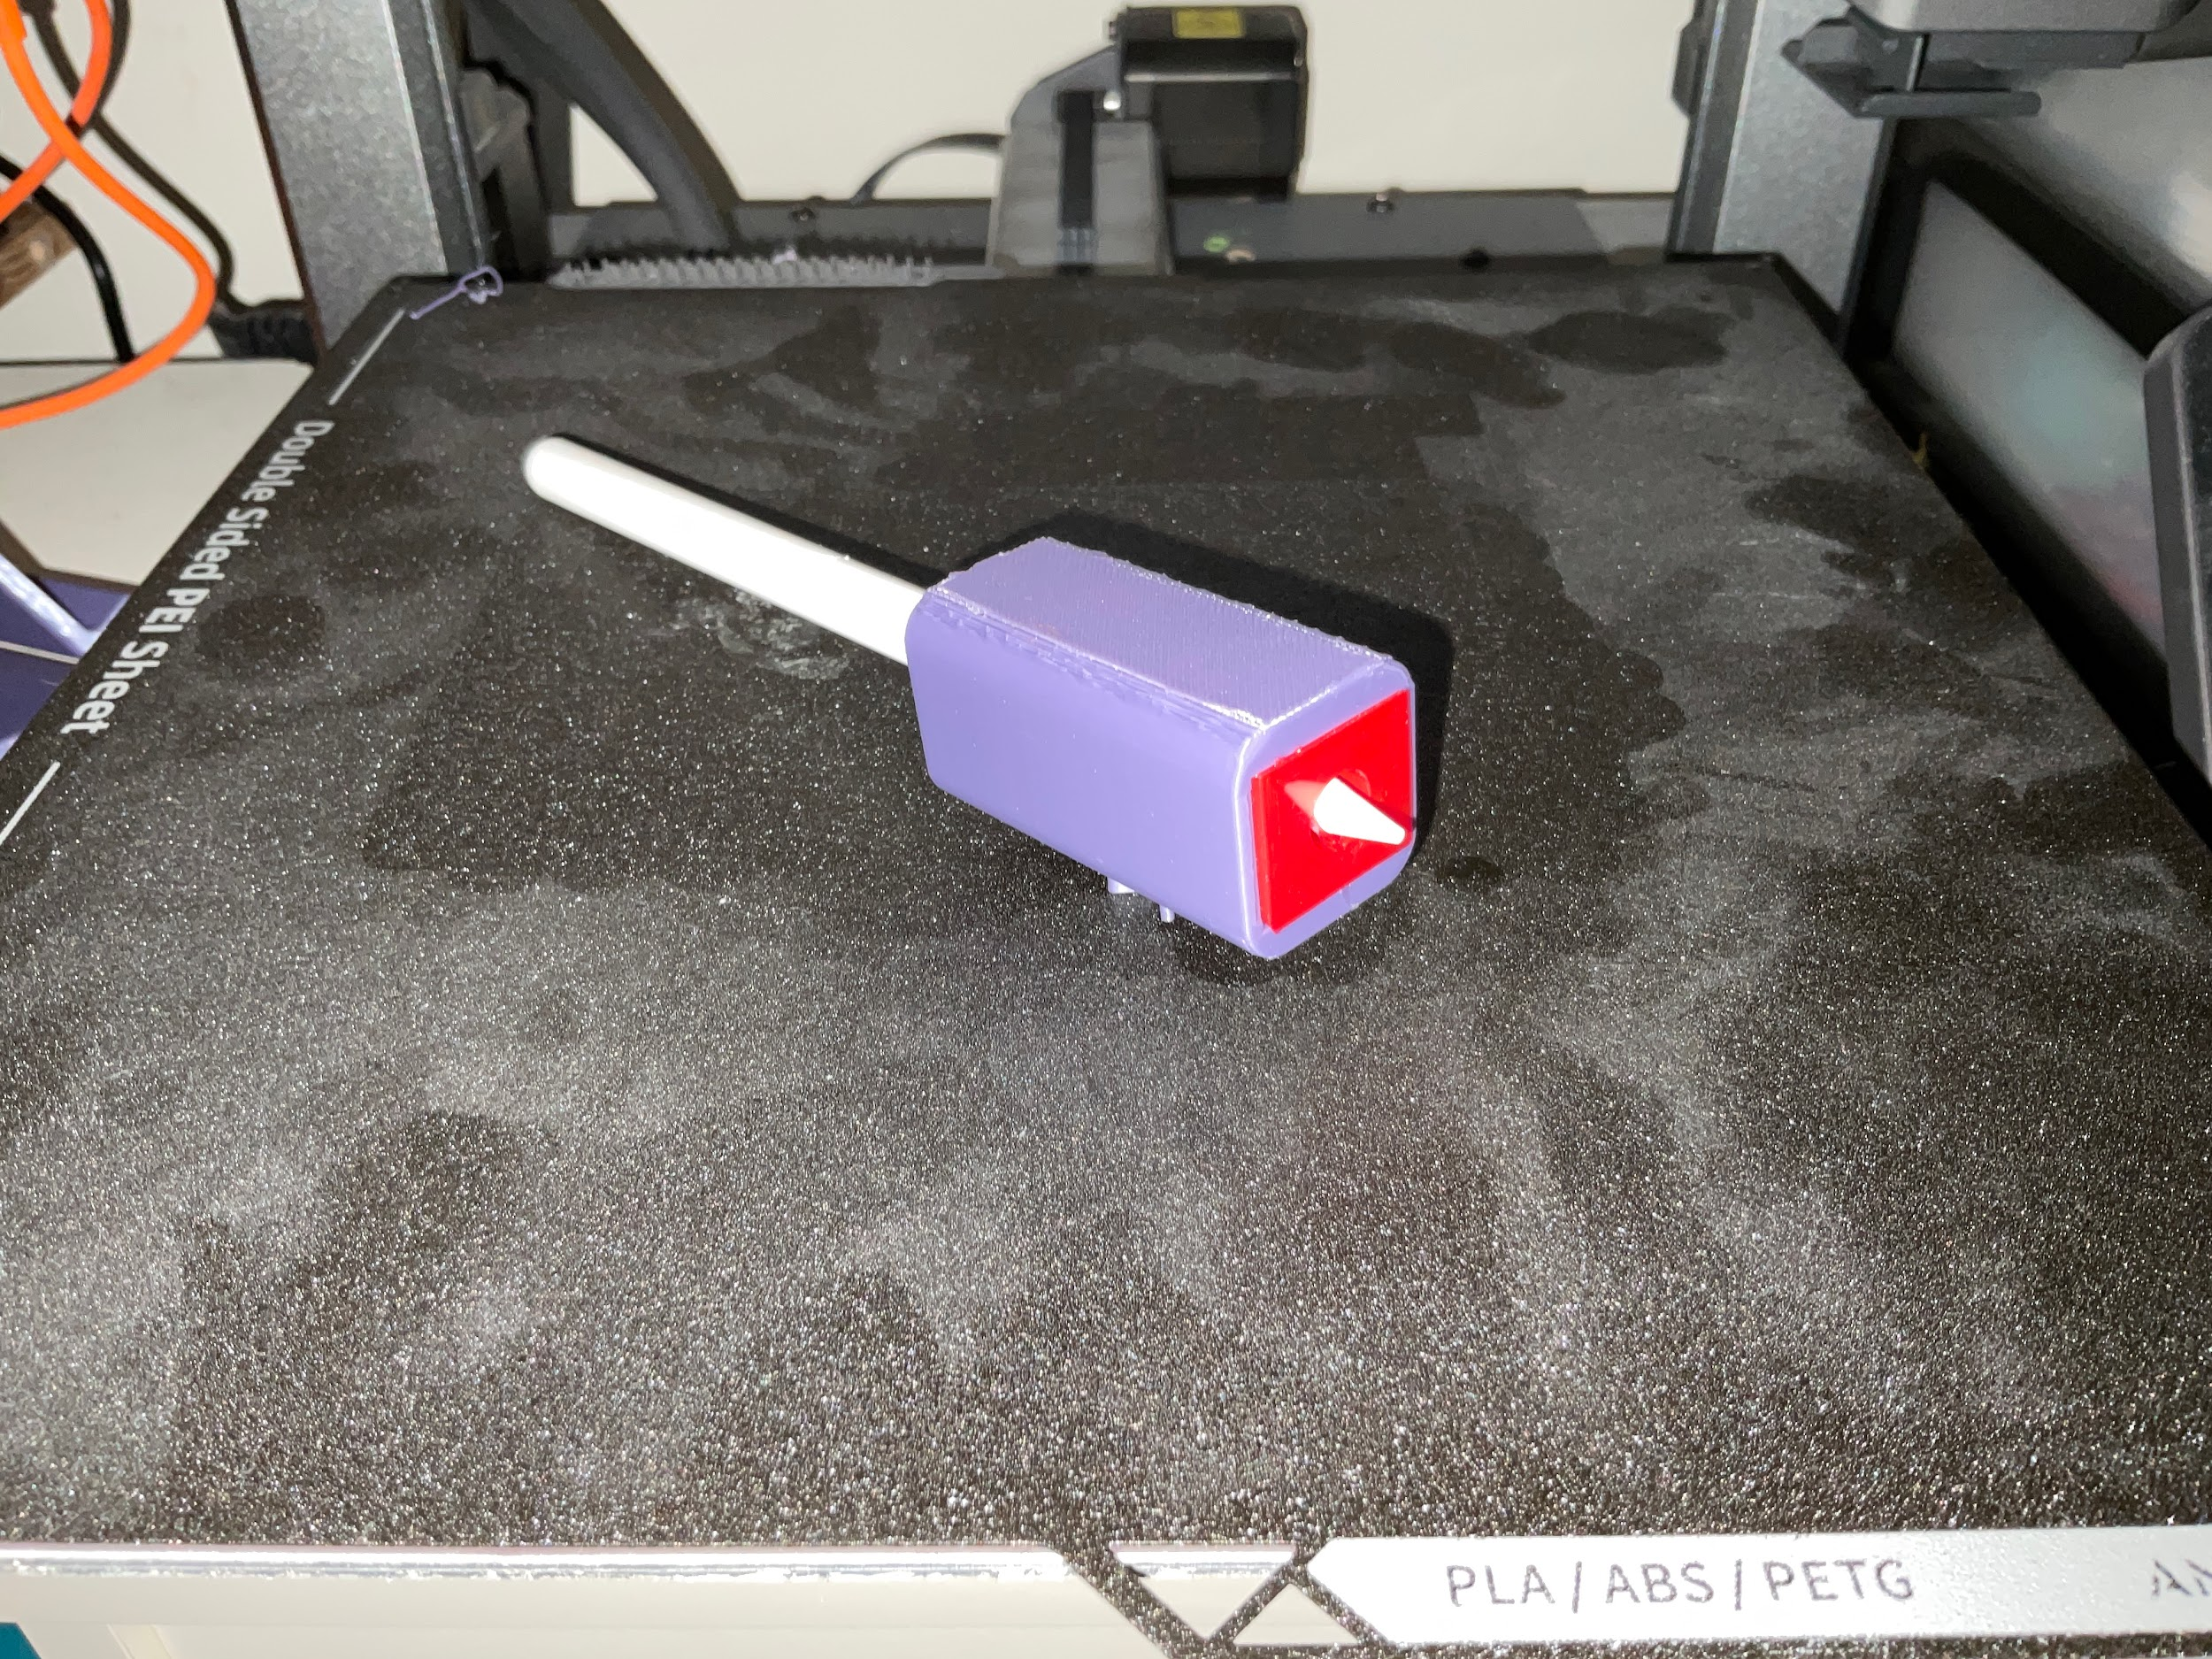

**Mobile Holder:**

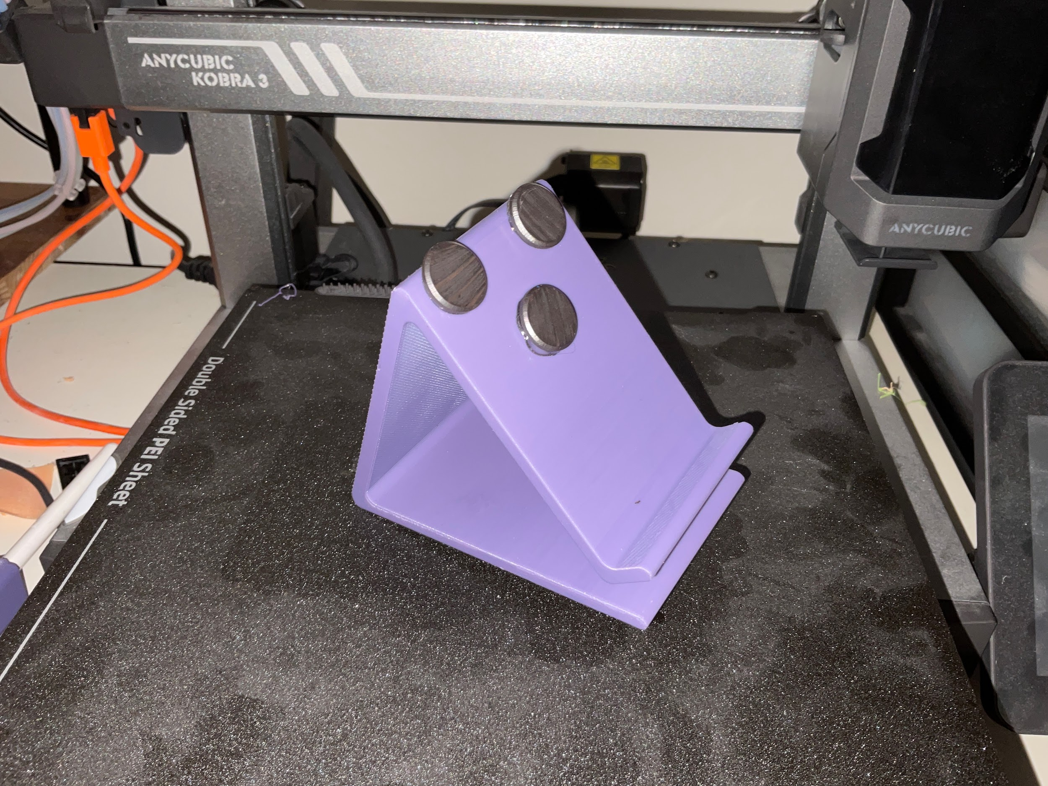

Details of the Print preparation in CURA, e.g., layer height, infill, print speed, etc.

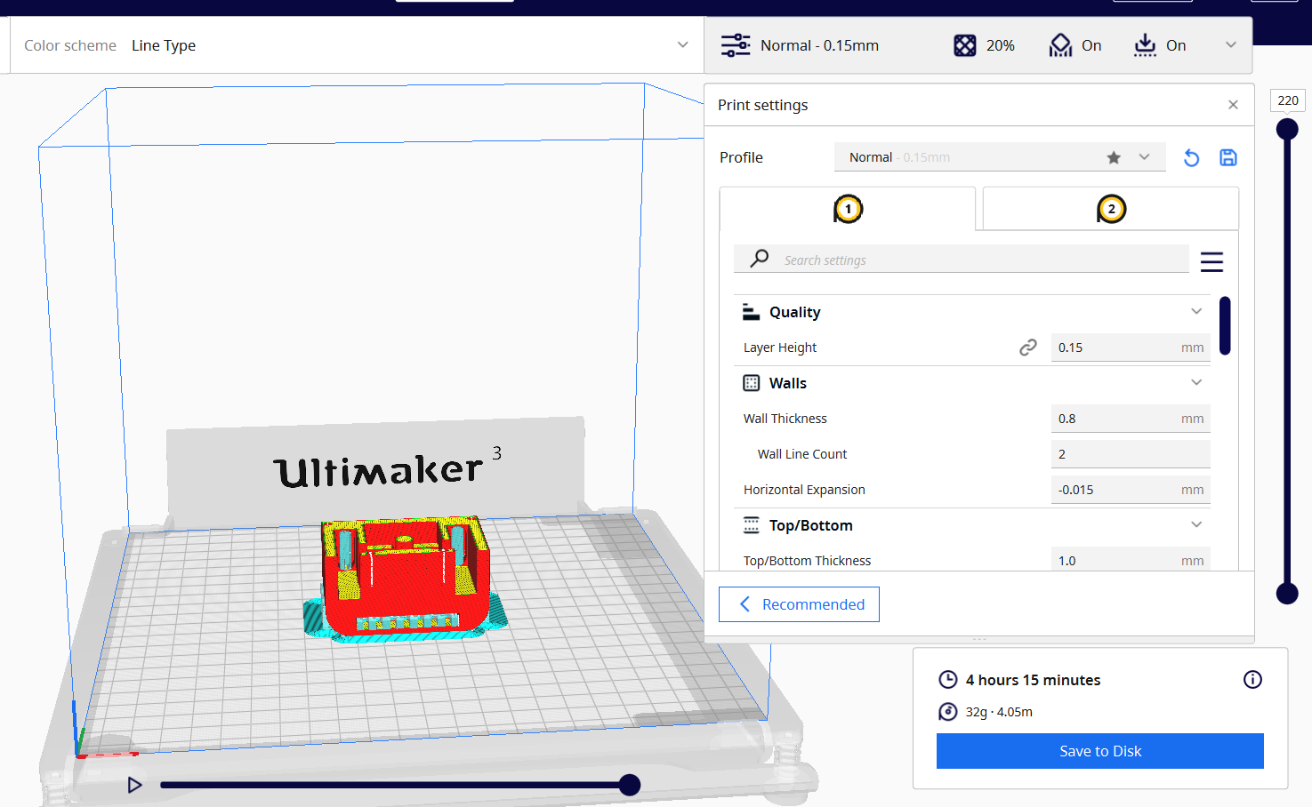

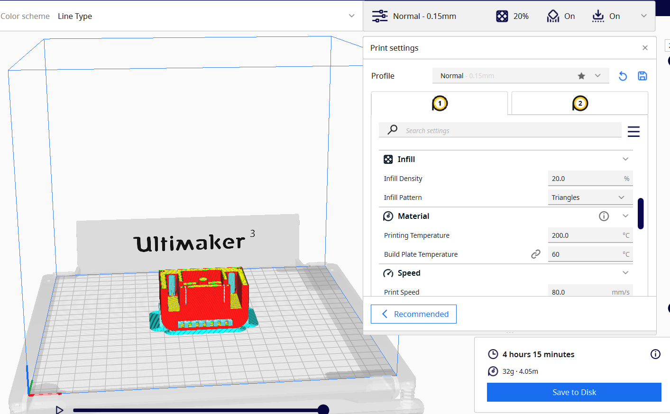

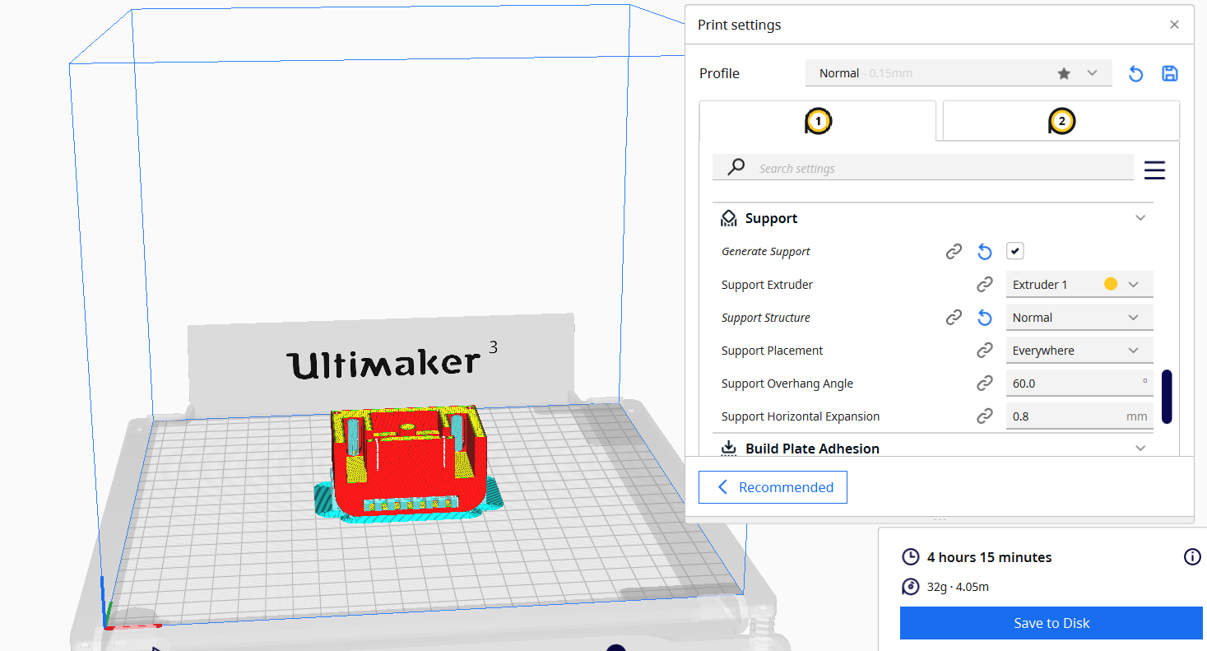

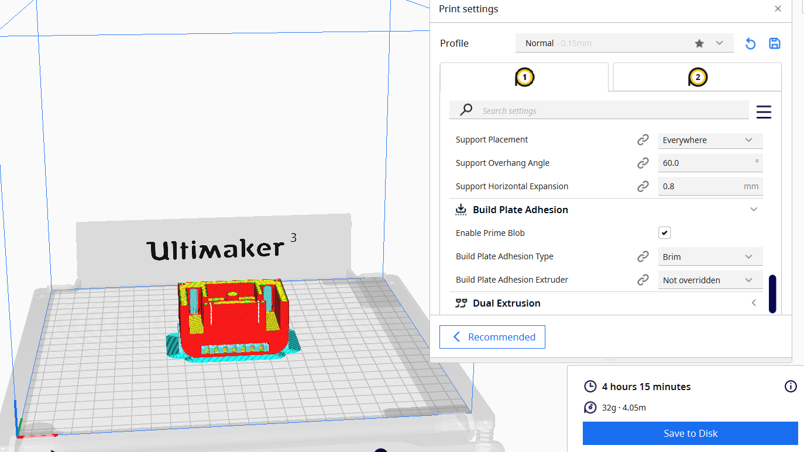

# Results from Testing

As the print shows, the prototype was successfully fabricated using PLA for the rigid base and TPU for the flexible locking mechanism. Upon manual testing, the device was evaluated for:

### **Testing Parameters**

|  |  |
| --- | --- |
| **Test Criteria** | **Observation** |
| **Fit & Comfort** | Device rested comfortably on the forearm; base edges caused no discomfort. |
| **Tool Holding Strength** | Adapter remained firmly in the slot without visible play or slipping under typical usage force. |
| **Locking Efficiency** | Stopper mechanism held tools in place securely; no rotation or detachment noted. |
| **Ease of Use** | Tool insertion and removal were quick and intuitive. |
| **Adjustability** | The tool adapter fit was universal within the X-slot dimension tolerance. |

### **Limitations Observed**

* Some minor stiffness was noticed in sliding certain tools into the slot
* When applying excessive force (>20 N), mild deformation was observed in the PLA base, suggesting material limits.

## Design Evaluation

|  |  |
| --- | --- |
| **Design Principle** | **Reflection** |
| **Innovative** | The new design includes an attachment that holds safety scissors in place and allows users to cut paper easily. Also, the new improved version of the Mobile holder is more stable and infallible. |
| **Useful** | The device helps users complete daily tasks independently, like cutting paper, which improves their self-reliance. |
| **Thorough** | The design was carefully planned, modeled, tested, and improved based on feedback to ensure it works well and safely. |
| **Minimal** | The deesign are very simple however there is a part where you need to screw in the Wrist mount to the Futa. |

# Open-Source repository

# Conclusion

In conclusion, this project successfully demonstrates the design and development of a wrist-mounted adaptive assistive device aimed at improving the quality of life for individuals with limited grip strength or wrist mobility. The final prototype incorporates a simple yet effective structure, consisting of a rigid base plate, a modular X-slot for interchangeable attachments, and a locking mechanism for secure tool placement. Using accessible 3D printing technologies and materials like PLA and TPU, the prototype was fabricated efficiently and tested for fit, functionality, and ease of use. Results confirmed that the device provides stable support, ergonomic comfort, and adaptability to different daily tasks such as eating or writing. Its lightweight, minimal design and modularity make it suitable for various users and use cases. Future enhancements could focus on material optimization and additional tool compatibility to further extend its usability. Overall, the device meets its intended purpose by promoting independence through a practical, low-cost, and user-friendly solution.